B00060572 David Kelly

**Introduction**

The brief asked for a system that could evaluate a happiness value determined by input values for a persons age, health and income. Although a persons disposition is not really quantifiable, using FuzzyLite it is possible to build a system to estimate how a persons disposition might be calculated by their situation.

I was asked to use three inputs Age, Health and Income and an output of disposition. I selected terms within each variable to describe a fuzzy value.

I created 5 terms within age as a person life can be long and have many different stages. I created 3 terms for Income because the average income tends to cover a large portion of the working class. Unable to find a measurement for health I also gave the variable 3 terms. Hoping to get more accuracy with the disposition output I created 5 terms to categorise their disposition.

**Linguistic Variables**

The system calls for real life inputs so to determine term values for the age I had to acknowledge that another variable of the system is income. To have an income a person generally must be old enough to be employed. I chose the minimum age to have a value of 15. The state age for a pension is around 65 years of age so I decided for that to be the maximum age.

Income again must have real life values. So I calculated the annual salary of minimum wage to be €15,000. I capped the maximum income of €75,000 because realistically the average salary is below that value and anything greater than €75,000 is still high which is the term used for the maximum input value. I decided to normalise the values for simplicity and set minimum equal to 15 and maximum equal to 75

Health is a tricky value to quantify as it doesn’t have state guides or official measurements. I researched some journals regarding how health can be measured but in truth nearly every piece of literature contradicted or provided alternative measurements. I decided to use 3 terms poor, average and good. As most of the population tend to be of average health I gave that value a greater size compared to poor and good. I set the minimum value equal to 0 for poor and maximum value equal to 1 for good.

Much like health, a persons disposition is difficult to quantify but for ease of understanding I gave each term equal size in a range 0 to 1. With 5 terms, minimum being 0 for miserable and maximum being 1 for ecstatic.

**Terms**

*Input Variables*

Age Terms: Young, YoungAdult, MiddleAged, Mature, Old :

***Young(15,15,25,30) YoungAdult(25,30,35,40) MiddleAged(35,40,45,50)***

***Mature(45,50,55,60) Old(55,60,65,65)***

Income Terms: Low, Medium, High :

***Low(15,15,30,35) Medium(30,35,55,60) High(55,60,75,75)***

Health Terms: Poor, Average, Good

***Poor(0,0,.15,.3) Average(.2,.5,.8) Good(.7,.85,1,1)***

*Output Variable*

Disposition Terms:

***Miserable(0,0,.1,.3) Sad(.1,.3,.5) Average(.3,.5,.7) Happy(.5,.7,.9) Ecstatic(.7,.9,1,1)***

**Decision Matrix**

The output values for the decision matrix aren’t as clear cut a the output values for the inverted pole. I tried to created realistic values for a persons disposition. The input variables tend to be weighted. Age is more important a factor than income in my opinion and health trumps both. Taking that in to account I created decisions matrices as shown below.

For example in a real world situation if your health is poor and your income is low regardless of your age you are going to be pretty miserable. The same can be said of health being poor and age being young, again regardless of your income you are going to be pretty miserable.

I tried to take in to account my disposition from experience and how I would imagine I would feel for certain inputs. To create rules for the output to work I used conjunction to put input variables together to determine an output. This can seem distorted but from what I found the output values seem to make sense. It’s less often that two inputs truly reflect your disposition. You may be sad about one situation but happy about another leaving your discrete disposition somewhere in between, an average if you will.

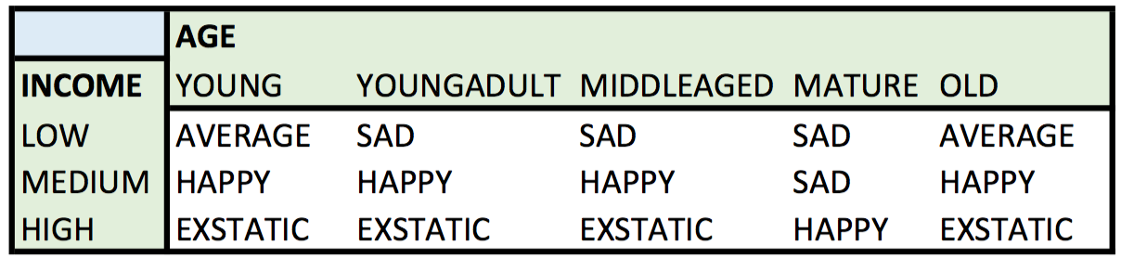

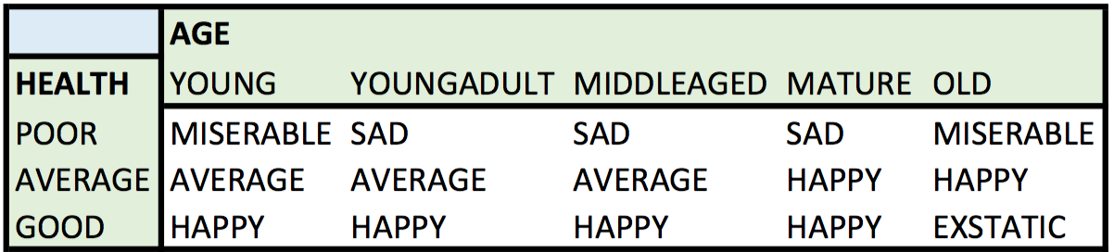

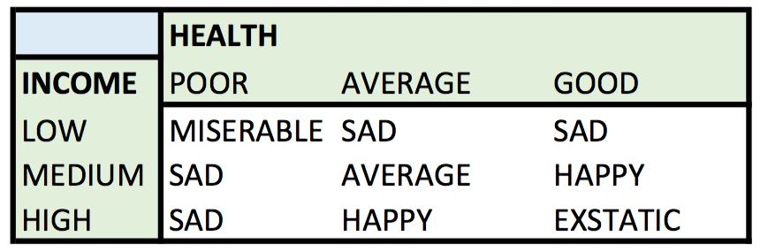

**Inference Rules**

Rather than giving all 39 inference rules I created I have provided a sample. When creating the rules that determine a persons disposition I tried to avoid reproduction of any rule that had the same output. In some cases it was unavoidable as it had a knock on affect when combined with the second input variable term. This means that membership of a disposition terms may not exist and can cause the centre of gravity for the output to be skewed and not reflect the real output value.

if (Health is Good) and (Age is Old) then Disposition is Ecstatic

if (Income is Medium) and (Age is MiddleAged) then Disposition is Happy

if (Income is Medium) and (Age is Mature) then Disposition is Sad

if (Income is Medium) and (Age is Old) then Disposition is Happy

if (Income is Low) and (Health is Poor) then Disposition is Miserable

**Screenshots**

Input: Age=45, Income=€49,980, Health=.8 (good)

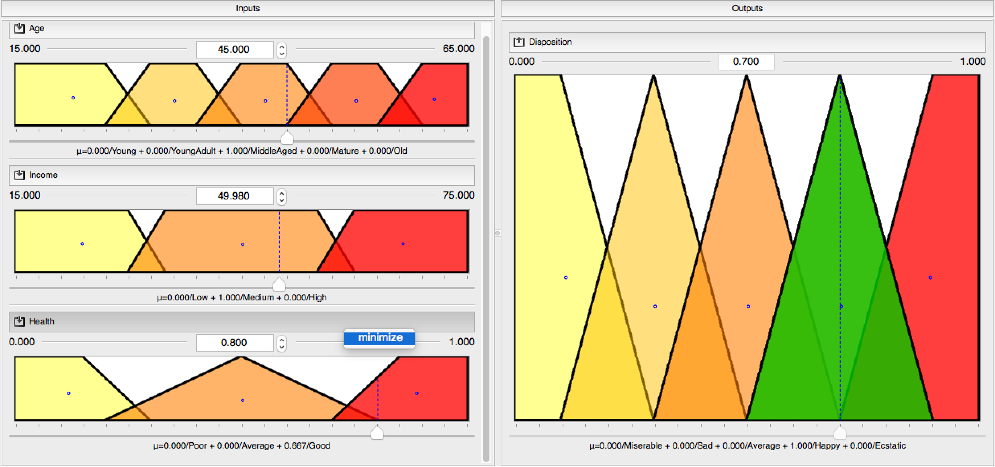

Output: Disposition=.7 (happy)

Input; Age=63, Income=€19,000, Health=.1(poor)

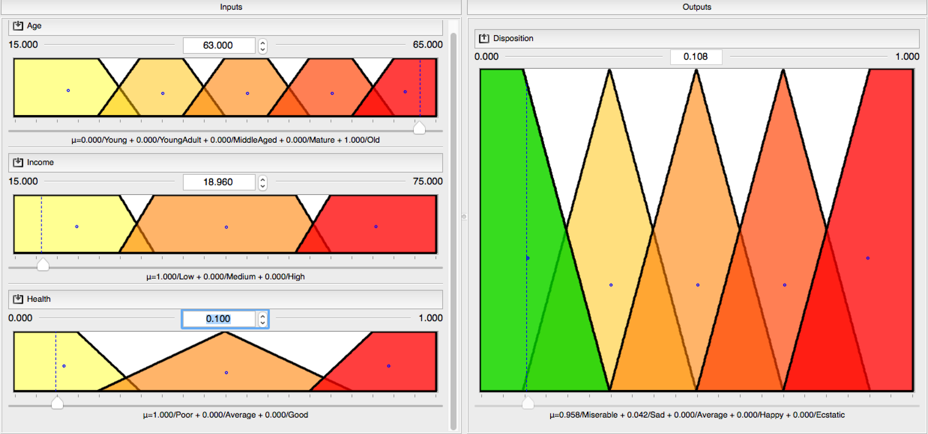

Output: Disposition=.1 (miserable)